Implementclusteringtechniques–HierarchicalandK-Means

AIM:

ToImplementclusteringtechniquesHierarchicalandK-MeansusingRprogramminginRStudio.

# HIERARCHIALCLUSTERING

#Loadtheirisdatasetdata(iris)

# Use only the numeric columns for clustering (exclude the Species column) iris_data<-iris[,-5]

#Standardizethedatairis_scaled

<-scale(iris_data)

#Computethedistancematrix distance_matrix<-dist(iris_scaled,method

="euclidean")

# Perform hierarchical clustering using the "complete" linkage method hc_complete<-hclust(distance_matrix,method ="complete")

#Plotthedendrogramplot(hc_complete,main="HierarchicalClusteringDendrogram",xlab

= "", sub = "", cex =0.6)

#Cutthetreetoform3 clustersclusters

<-cutree(hc_complete,k=3)

#Printtheclustermembershipsprint(clusters)

#Addtheclusterstotheoriginaldatasetiris$Cluster

<-as.factor(clusters)

#Displaythefirst fewrowsoftheupdateddatasethead(iris)

# OUTPUT:

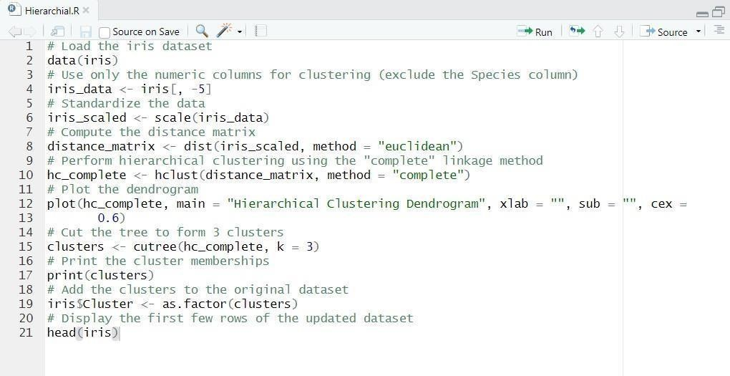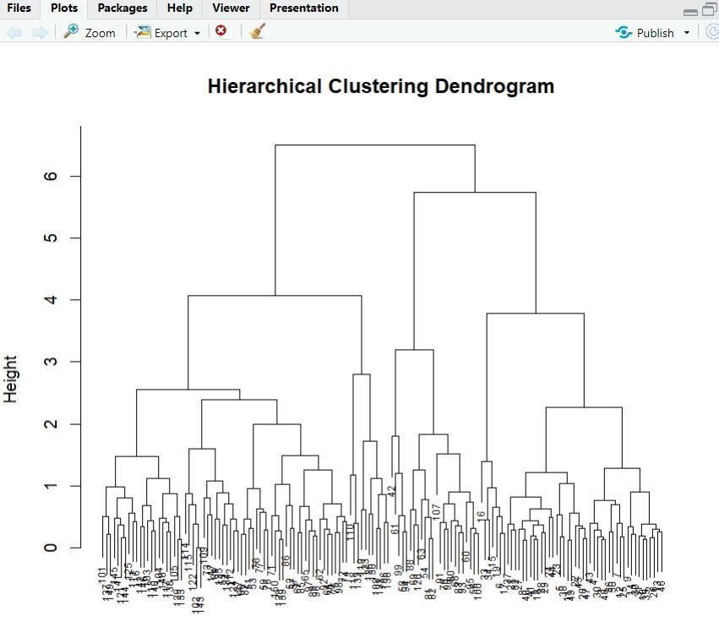

1. **K-MEANSCLUSTERING**

#Loadtheirisdatasetdata(iris)

# Use only the numeric columns for clustering (exclude the Species column) iris_data<-iris[,-5]

#Standardizethedatairis_scaled

<-scale(iris_data)

# Set the number of clusters set.seed(123)#For reproducibility k <-3

#Numberofclusters

#PerformK-Meansclustering

kmeans_result<-kmeans(iris_scaled,centers=k, nstart =25)

# Print the K-Means resultprint(kmeans_result)

# Print the cluster centersprint(kmeans_result$centers)

#Addtheclusterassignmentstotheoriginaldatasetiris$Cluster<-as.factor(kmeans_result$cluster)

#Displaythefirst fewrowsoftheupdateddatasethead(iris)

# Plot the clusters library(ggplot2) ggplot(iris, aes(x = Sepal.Length, y = Sepal.Width, color =Cluster))+ geom_point(size= 3) + labs(title = "K-Means Clustering of Iris Dataset", x = "SepalLength",y ="SepalWidth") **OUTPUT:**

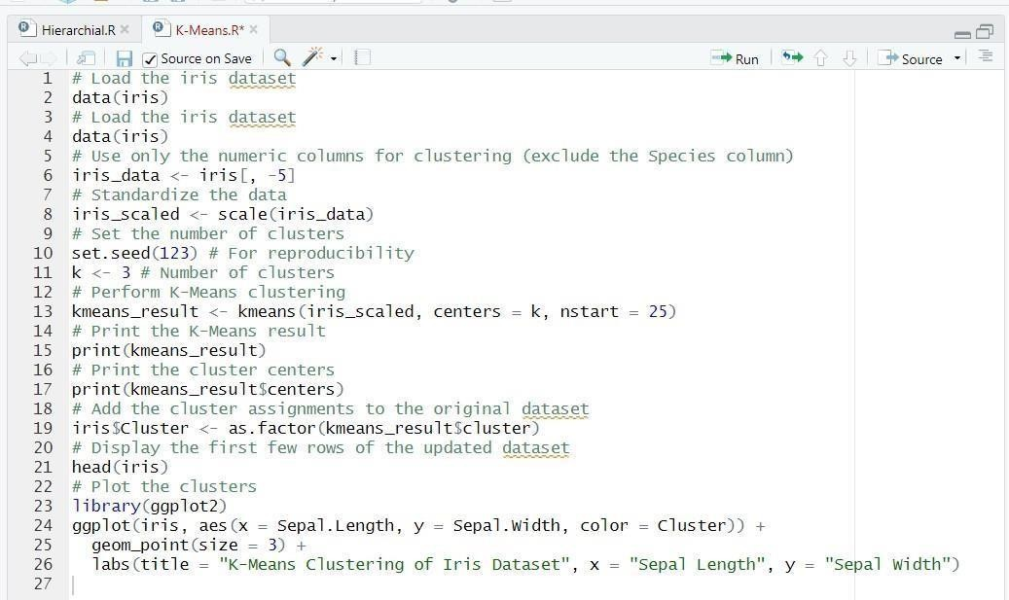

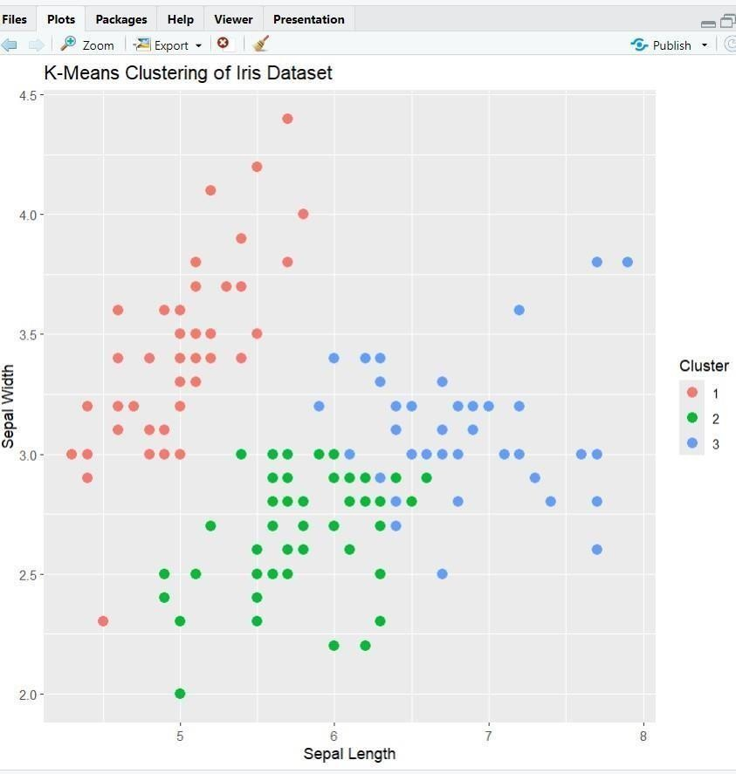

# RESULT:

Thus, the Implement clustering techniques Hierarchical and K-Means using R programming in RStudiohavebeen successfully executed.